The relationship between agriculture and food, fiber, and energy
Pillar 2 C. Explain how energy availability impacts communities
(9th – 12th Grade)

Website: http://www.ucsusa.org/sites/default/files/legacy/assets/documents/clean_energy/renewablesready_fullreport.pdf
Hands On: http://www.ucsusa.org/sites/default/files/legacy/assets/documents/clean_energy/renewablesready_fullreport.pdf
http://www.agclassroom.org/teacher/matrix/lessonplan.cfm?lpid=485&grade=9&author_state=0
Video: https://www.youtube.com/watch?v=6Nf99ITbO7A&index=9&list=PLACD8E92715335CB2

Energy and the Commodity Trace-back

Purpose
In this lesson students will describe the domestic food supply chain and identify the use and types of energy involved in the growth, harvest, processing, transportation, and marketing of an agricultural commodity.

Materials
- Energy and Commodity Trace Back PowerPoint
- Energy Transmission Cards
- Hardboiled or plastic eggs (1 per group of 3-5 students)
- Note paper (1 per group of 3-5 students)
- Computer lab access (1 computer per group of 3-5 students)
- Energy in the Food Chain Handout (1 per student)

Essential Files (maps, charts, pictures, or documents)
- Energy in the Food Chain handout
- Energy Flow Transmission Cards
- Energy and Commodity Trace-back PowerPoint

Vocabulary
Chemical energy: energy stored in the bonds of chemical compounds and then released in a chemical reaction
Energy: power derived from the utilization of physical or chemical resources, especially to provide light and heat or to work machines
Kinetic energy: energy that a body possesses by virtue of being in motion
Potential energy: the energy stored by an object
Radiant energy: energy from sunlight
Transformer: an apparatus for reducing or increasing the voltage of an alternating current
Background Agricultural Connections
Energy is a part of our daily lives. Whether it is flipping a switch to turn on a light bulb or plugging in a kitchen appliance to prepare dinner, it plays a role in almost everything we do.

Interest Approach – Engagement
- As students enter the class, challenge them to silently think of five things they do each day that require energy. When they have five things in mind, they are to hold up a hand showing five fingers. Gather examples from a few students and then explain that energy is something we depend on every day. Energy is amazing, because it is never created or destroyed. It also cannot be stored in large quantities, so it must be harnessed/generated when it is needed. By the time students leave class, they will know how energy is made, how it gets to their homes, and how it is used in the process of food production.
- First, determine the source of energy by playing a game called, "Top Ten." Divide the class into groups of 3-5 students. Display slide 2 of the Energy and Commodity Trace-back PowerPoint. Instruct the students to rank these 10 sources of energy in order from the highest to lowest in use. After each team has completed this task, use slide 3 to give the answers. Have the students tally their score. Reward the winning team.
- Ask students to share observations about the list. Ask questions to stimulate thinking such as, "Why do you think petroleum is highest on the list?" (it is used in vehicles.) "How many of these energy resources are renewable?" Clarify that energy is often generated in one form (i.e., wind) and converted into another form (i.e., electrical).
- Now that students know where energy is produced, ask if they know how it is actually distributed. Explain that one of the challenges of producing energy, just like producing our food, is that energy is often harnessed (generated) in a place other than where it is used. Energy, like food, must be transmitted/distributed.
- Break students into groups of 3-5. Each group will receive a set of Energy Transmission Cards. Groups will have four minutes to review their cards and place them in order from the generation plant to the end user at home.
- Give each team a set of Energy Transmission Cards. After teams have attempted to place cards in order, ask volunteers to share and defend why they placed the cards in this order. Listen for their rationale. The objective of this exercise is not accurate placement, but building awareness of the many factors that affect energy production and transmission.
- When sufficient volunteers have shared, reveal the correct placement and rationale using PowerPoint slide 4.
- Ask students how our food supply and energy consumption are related. Provide guiding questions such as, "Do farms require energy? Does it require energy to process our food? How is food transported between the farm and the consumer?"

Procedures
Activity 1: The Backwards Egg and The Domestic Food Supply Chain
- Organize students into groups of 3-5 and distribute one hardboiled or plastic egg to each group.
- Have students place the egg in the center of their notepaper and create a mind web around the egg, brainstorming all of the points where energy was used to produce it. If students have trouble starting this activity, provide them with a few of the items in the example list below.
- Ask them to place these items on the mind web and continue brainstorming.
- Have students think backward first. How has energy been used to produce this egg and get it here? (PowerPoint slide 7) For example:
  - Egg
  - Refrigeration at grocery store
  - Grocery store employee stocking shelves
  - Transportation of eggs
  - Cleaning and packaging egg
  - Chicken
  - Feeding the chicken
  - Housing and lighting, cooling, heating
  - Water for chicken/energy to pump water
  - Delivering feed for chicken
  - Growing feed for chicken
  - Sun
- Then ask students to think forward. How will energy be used with this egg before it is consumed? For example:
  - Refrigeration
  - Mixer
  - Electrical or gas stove
- After groups have completed their mind webs, ask groups to share by playing “Back and Forth.” One group starts by saying the first item on their list. Then, the next group shares one of their energy inputs without repeating. Continue calling on groups around the room until the groups have shared all they can. The group that adds the last energy input to the list wins! Write the energy inputs on the board as each group shares them.
- Explain to the class that the energy inputs they have listed represent the path from producer to consumer that all food products go through.
- Using Power Point slide 8, introduce the domestic food supply chain:
  - Farm production
  - Food processing and brand marketing (processing)
  - Food and ingredient packaging (packaging)
  - Freight services (transportation)
  - Wholesale and retail trade and marketing services
  - Away-from-home food and marketing services (food service)
  - Household food services (households)
- While continuing to display the domestic food supply chain ask the students the following questions:
  - Which step or steps do you think require the most energy today? (Answers can vary. Some foods have high energy requirements and others are low.)
  - Do you think this chain requires more or less energy than it did 100 years ago? (More)
  - What has changed in food production and processing that requires more energy use to obtain our food? (Increased technology and mechanization, food can travel farther distances to reach the consumer, higher levels of food processing to prepare "convenience foods")
    - Background: Research was conducted on adults between ages 18 and 64. The study found that time per day spent cooking at home dropped from 65 to 31 minutes per day between 1965 and 1995. People spend less time preparing food at home now, because we have access to “convenience foods” — foods that are ready to go right out of the package. This means that, while there is less energy spent at home preparing meals, more energy is spent by manufacturers who are preparing convenience foods.
  - Why do you think it might be valuable to look at energy use in the food supply chain? (Listen for observations that reference the cost of energy or the environmental impact of energy used at each step.)

Activity 2: Commodity Investigation
Note to teacher: This activity can be performed in groups or by individual students.
- Assign a commodity to each group (or individual student). Possible commodities include corn, soybeans, rice, potatoes, oranges, grapes, strawberries, steak, apple, flour, milk and so on.
- Give each student one Energy in the Food Chain handout.
- Using the PowerPoint slide 9, remind students that there are multiple types of energy.
- Instruct groups to research the energy involved in each step of producing their assigned commodity and the type of energy used. Groups should address the following questions as they complete their Energy in the Food Chain handout.
  - Where is this commodity primarily grown/raised? What energy is used?
  - When is it planted/harvested? What energy is used?
  - How is it planted/harvested? What energy is used?
  - How is the raw product commonly processed and/or packaged? What energy is used?
- Optional: If time allows, you may wish to have groups create a diagram mapping the flow of energy for their commodity.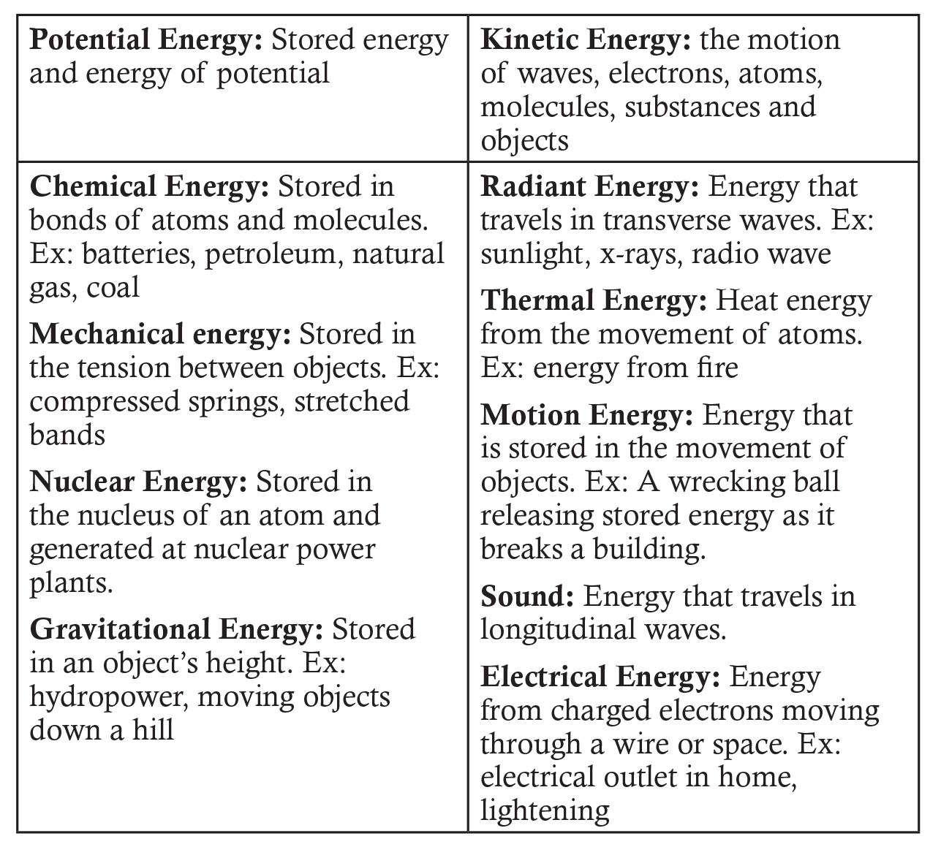

Concept Elaboration and Evaluation
After conducting these activities, review the following key points:
- Almost everything in our lives requires energy. Our food production system is no exception!
- To maintain a stable food supply, it is important to have a variety of energy sources available for these activities that feed, clothe and house us.
- Energy is produced through petroleum, wind, hydropower, biofuel, natural gas, solar, geothermal, nuclear, wood, and coal sources.
- After energy is produced it is stored and then transmitted to homes, farms, and businesses for use.

Enriching Activities
- Provide a Career tie-in by assigning a livestock commodity to each group (or individual student). Possible commodities include hogs, cattle, sheep or goats. Instruct students to put themselves into the mindset of an Animal Nutritionist. Through research, students will design a sack feed for the livestock species of choice by looking at all aspects of producing that feed (soil preparation, planting, harvest, etc.). In their research, they are to look at the energy involved in each step of producing that commodity and the type of energy. To conclude, challenge students to mentally walk through the processes of creating a sack feed. As an animal nutritionist, what are some of the key factors that go into creating a balanced feed ration?
- Share the video clip, Energy 101.
Sources/Credits
This unit was funded by the United States Department of Agriculture’s National Institute of Food and Agriculture, Secondary Agriculture Education Challenge Grants Program. The high school unit STEM Connections - Energy and Agriculture - Careers in Sustainable Energy was created to foster an appreciation for agriculture, reinforce STEM skills, and create an awareness of agriculture-related careers in students while meeting the needs of California’s teachers.

