The relationship between agriculture and lifestyle
Pillar 4 B. Identify agricultural products that provide valuable nutrients for a balanced diet (Grades 4th – 8th)

Website: https://www.agclassroom.org/teacher/matrix/lessonplan.cfm?lpid=546
http://www.agclassroom.org/northdakota/matrix/lessonplan.cfm?lpid=546
Hands On: Have students make themselves a menu for either the day or the week with healthy food choices. Identify the raw farm foods from those menu items. (Pizza = wheat, tomatoes, dairy (cheese), pig (sausage/pepperoni), mushrooms, green pepper, etc.) fries (potatoes), etc.
Digital: Also play the game City Farm https://tn.pbslearningmedia.org/resource/sust13.sci.eco.cityfarm/city-farm/#.WVPVyjO5D-Y

Activity: Understanding MyPlate
Digital Activity: Play the game City Farm https://tn.pbslearningmedia.org/resource/sust13.sci.eco.cityfarm/city-farm/#.WVPVyjO5D-Y

Understanding MyPlate

Purpose
Students will explore appropriate serving size and learn how to make good dietary decisions by understanding the components of nutrition as illustrated by MyPlate.

Materials
Activity 1
- Paper plates, 1 per student
- Glue or glue sticks
- Crayons or colored pencils
- Scissors
- Grocery store ads, magazines, or anything else with pictures of food for students to cut out
- Food Models kit
- Coordinating shopping lists and grocery ads (see activity sheet)
- Healthy Choices activity sheet, 1 per student
Activity 2
- Beverage containers
- Think Your Drink chart

Essential Files (maps, charts, pictures, or documents)
- Health Choices Activity Sheet
- Think Your Drink Chart

Vocabulary
MyPlate: nutritional guide published by the United States Department of Agriculture; icon depicting a place setting with a plate and glass divided into five food groups

Did you know? (Ag Facts)
- Using the Nutrition Facts on food labels will enable you to eat healthier and make wiser food choices. Select foods that are low in fat and sodium.
- The Percent Daily Values (% DV) is a general guide for linking nutrients in one serving of food to their contribution to your total daily diet.
- Most Americans don't receive enough vitamins A and C, potassium, calcium, and iron; therefore select foods with a higher % DV for these nutrients.
- Water can be your best friend. Flavored teas, sodas, sport drinks, and juices can add as much as 400 calories to your meal whereas water has no calories at all and helps you feel full.
- Meals that are cooked and prepared at home rather than purchased at a restaurant have fewer calories and can be monitored more closely for healthier options.

Background Agricultural Connections
The USDA MyPlate icon uses a familiar and relatable image to help us balance our diets, eating from all five food groups proportionally. MyPlate identifies each of the food groups with a different color and a proportional section of the meal setting. The icon provides a visual reminder to make half of your plate fruits and vegetables. The USDA dietary guidelines include a few more basic recommendations to help Americans make healthy food choices: eat a variety of different fruits and vegetables, make half of your grains whole grains, eat a variety of protein foods, and choose low- and nonfat dairy products. Foods with added fats and sugar should be eaten only occasionally, and processed foods should be eaten in moderation.

Interest Approach – Engagement
- Prepare a basket with as many of the following items as you can find: apple, peanut, corn, beans, cantaloupe, green pepper, strawberry, carrot, potato, tomato, eggs, onion, watermelon, popcorn, rice, hot dogs, and ham. You may call on parents or volunteers to help provide these items. As an alternative, you could also use pictures or Food Model cards.
- Call on students to choose an item from the basket and tell why they chose this item. Ask students the following questions to help them connect the food they eat each day to the farm(s) that produce it:
  - Do you like to eat this type of vegetable, fruit, or meat?
  - Where can you purchase these items?
  - How do these items get to the grocery store?
  - How are these foods grown?
  - Who grows these foods?
  - What would you eat if farmers didn't grow these foods?

Procedures
Activity 1: Choose MyPlate
- Review MyPlate with students, and discuss the role of nutrition in growth and development.
- Provide each student with materials: crayons, scissors, glue, paper plates and an assortment of grocery store ads and other food pictures.
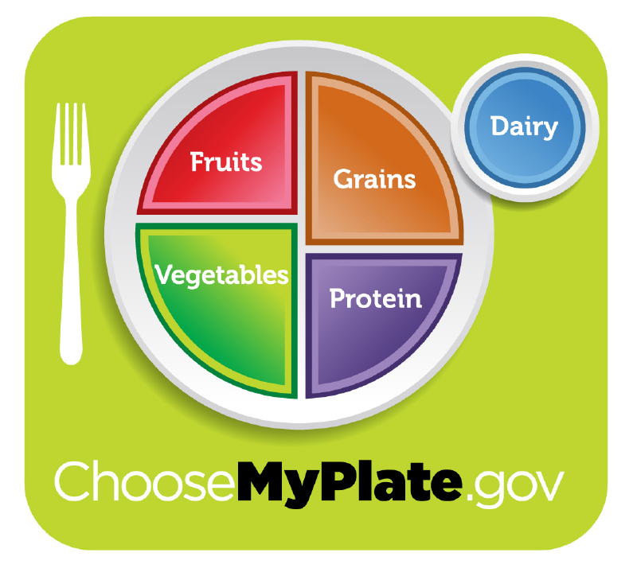
- Ask students to create their own replica of MyPlate by sectioning off their plate with the different food groups. Include a paper circle cut-out to the side for dairy. It may be helpful to display the MyPlate Activity Poster so that students can reference it to create their own plate.
- Have students cut out foods from the grocery store ads and food pictures and glue them onto their plate to create a healthy “meal.”
- Discuss the importance of balance in a diet and making healthy choices. Ask students if the meals they created with food cut outs represent a balanced meal. How many servings did they include in each food group? How many of the foods they chose are highly processed?
- Identify serving sizes of various foods in each food group. The Food Models kit is an excellent resource for providing a visual representation of serving sizes. If you use the Food Models, have students place them on their plate in the correct food group, building a meal in which approximately half of the servings come from fruits and vegetables. If you do not wish to use Food Models, information on portion sizes can be found on the USDA website, and serving size equivalents that are easy to visualize can be found on the Nourish Interactive website.
- Provide students with grocery ads and shopping lists that call for specific quantities of five items included in the ads.
- Have students complete the activities on the accompanying Healthy Choices activity sheet.
  - Answer key to hamburger servings: bun = 2 grain servings, 1/2 cup onion & tomato = 1 vegetable serving, 1 oz. cheese = 2/3 milk serving, 3 oz. beef patty = 1 meat serving.

Activity 2: Think Your Drink
- Ask the students to name different drink choices, and list their responses on the board.
- Show the class some beverage containers. Ask the students how we can tell if drinks are healthy or not. Show the locations of the nutrition fact labels on the containers. Explain that we can look at the nutrition fact labels to determine whether or not drinks are healthy. These labels tell us what ingredients are inside our drinks and how many calories, sugars, fats, vitamins, and minerals the drinks contain.
- Provide each student with a copy of the Think Your Drink chart or project the chart for the whole class to see. Explain to the students that when choosing healthy drinks they should specifically consider the amount of calories and sugars compared to vitamins and minerals.
- Ask the students to use the Think Your Drink chart to determine which drinks on the class list are healthy choices. Explain that water, low-fat milk, and 100% juice are healthy drink choices. Water is essential for our bodies and contains no sugar or calories. Low-fat milk contains calcium which is important for overall health. When we aren’t getting enough calcium in our diets, our bodies take calcium from our bones, which causes our bones to weaken. 100% juice provides us with important vitamins and minerals, but also contains natural sugars. Daily intake of 100% juice should be limited to 8 ounces for adults and 4-6 ounces for children. Eating whole fruits is a better option for obtaining these vitamins and minerals.

Concept Elaboration and Evaluation
After conducting these activities, review and summarize the following key concepts:
- A healthy diet includes fruits, vegetables, grains, protein, and dairy.
- Farmers produce the food we eat.
- It's important to eat the right amount of each food group to obtain the nutrients our body needs.

Enriching Activities
- Make a MyPlate snack. Have students invent a snack that includes foods from each food group. For example, start with half of an English muffin or a firm cracker. Spread the top lightly with peanut butter. Add shredded carrots and chopped apples. Serve with milk.
- Identify the types of farms and the states where foods on the plate come from. Find out how long the crop or animal is grown to create an edible product delivered to your table.
- Create a giant plate on one of your classroom walls. Ask students to cut out more magazine pictures or draw pictures of the foods that belong in each group and then place them on the wall. Alternatively, you may want to attach the actual containers to the appropriate food group. Consider asking students to bring in empty food containers.
- Further explore the importance of a balanced diet in human health and what this means for vulnerable populations around the world using the lesson plan Hunger and Malnutrition.

Suggested Companion Resources
- Fill MyPlate Game (Activity)
- Food Group Puzzle (Activity)
- Higher or Lower: Ingredient Investigation (Activity)
- Portion Size Comparison (Activity)
- Food Models (Kit)
- MyPlate Activity Poster (Poster, Map, Infographic)
- The Power of Choice Bulletin Board (Poster, Map, Infographic)
- Eat & Move O-Matic (Multimedia)
- Food Doesn't Grow in the Supermarket! (Multimedia)
- Choose MyPlate (Website)
- Food-A-Pedia (Website)
- Nutrition Facts Label Programs and Materials (Website)

